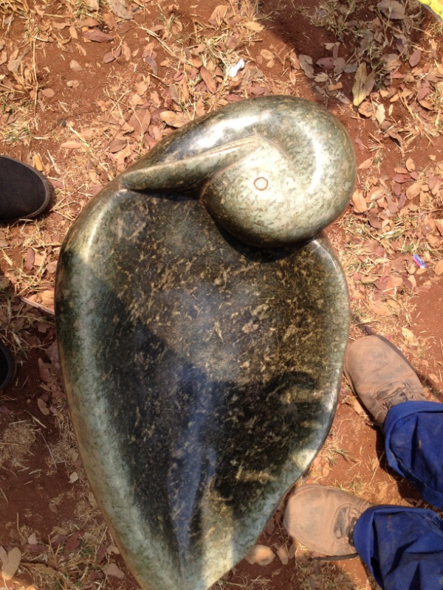

Bird Bath

Size: Length: 15cm
Width: 53cm
Lower Size: 31cm
Type of Stone: Nyava Stone from Nyava

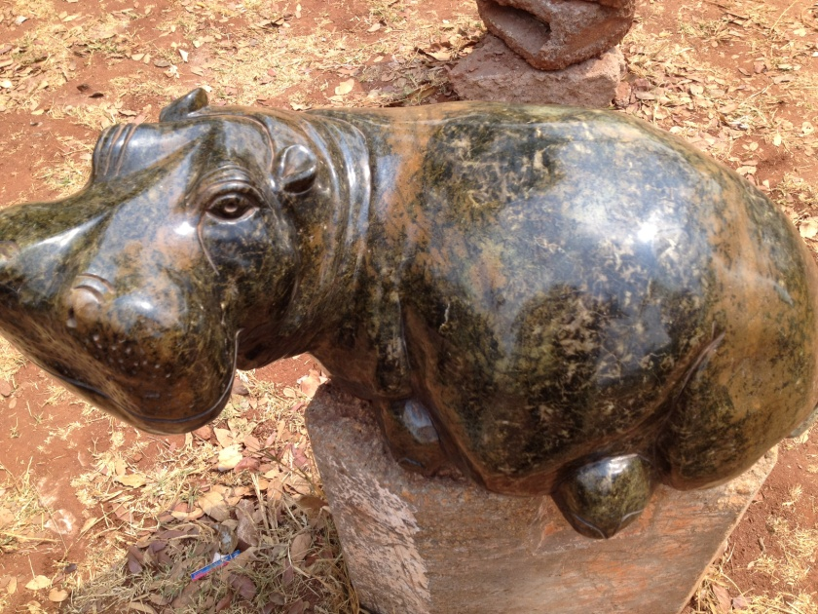

Sleeping Hippo

Size: Length: 33cm
Width: 65cm
Lower Size: 43cm
Type of Stone: Nyava Stone from Nyava

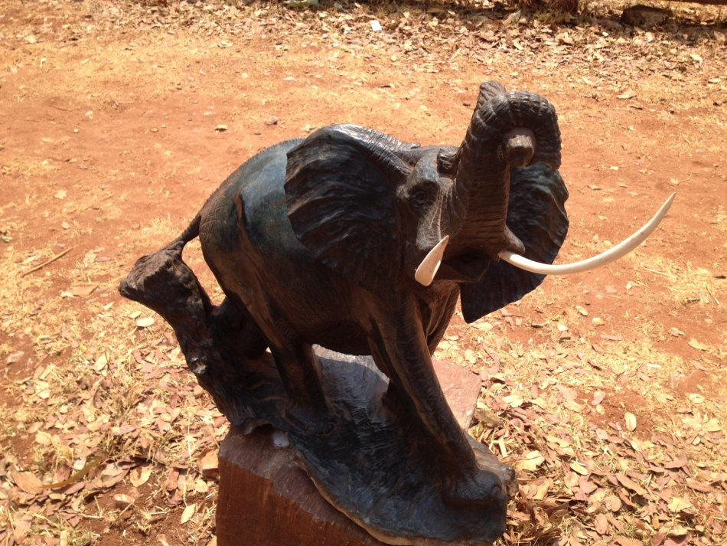

Charging Elephant

Size: Length: 64cn
Width: 65cm
Lower Size: 40cm
Type of Stone: Fruit Stone from Kwekwe

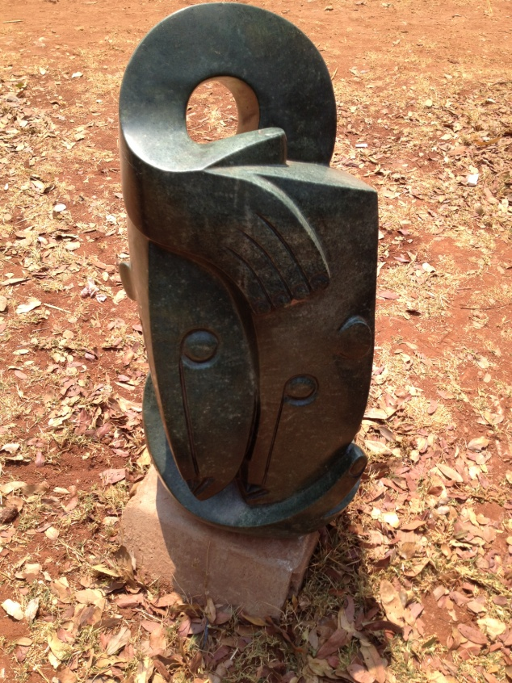

United Brothers

Size: Length: 74cm
Width: 39cm
Lower Size: 30cm
Type of Stone: Opal Stone from Chiweshe
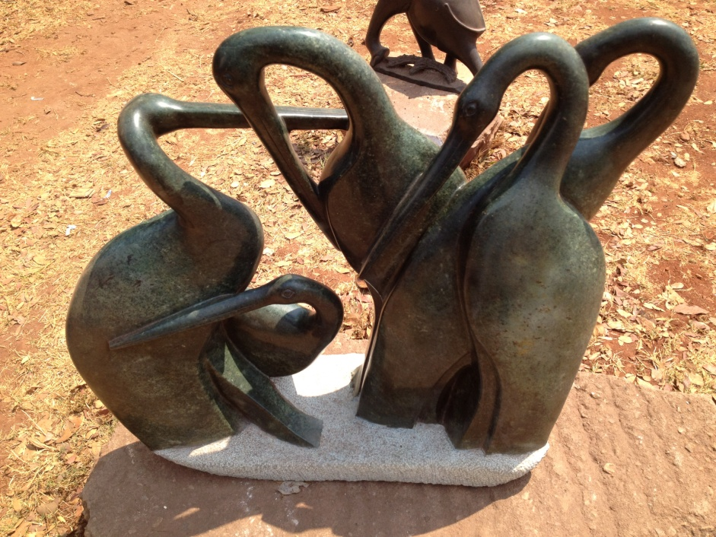

Stork Birds

Size: Length: 75cm
Width: 76cm
Lower Size: 30cm
Type of Stone: Opal Stone from Chiweshe

